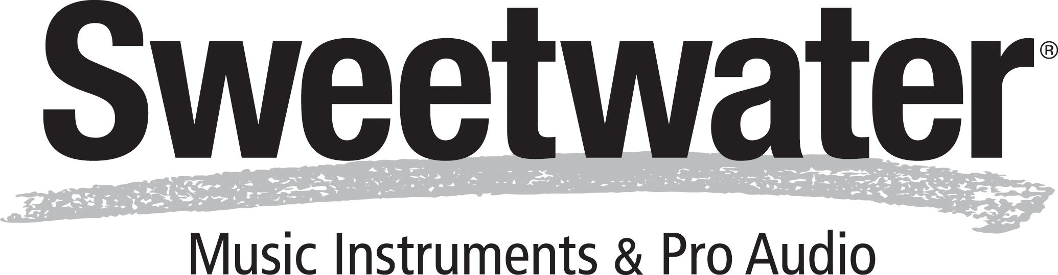
Quote Number 11113938
Quote Date 10/8/25
Delivery Method Multi-Campus Delivery

5501 US HWY 30 W
Fort Wayne, IN 46818 (800) 222-4700
Sweetwater.com

Customer Number
93351

Quote To:
David Smith
NYC College of Technology 300 Tillary Street 11201
Center for Holistic Integration LG-Brooklyn, NY 11201

Ship to:
David Smith
NYC College of Technology 300 Tillary Street 11201
Center for Holistic Integration LG-Brooklyn, NY 11201

Qty. | Item | Description | Your Price | Total
1 | ORIA | Audient Audio Interface | $3,499.99 | $3,499.99
1 | ImmersiveSysN1 | 4" KH Series Monitor Immersive Audio Bun
1 | KH750 | Neumann 10" 256W Active KH Sub | $1,750.00 | $1,750.00
1 | MA1mic | Neumann RTA Measurement Mic | $299.00 | $299.00
11 | KH80 | Neumann 4" KH Series Monitor (ea) | $549.00 | $6,039.00
Tax Exempt Certificate

Subtotal: | $11,587.99
Shipping & Handling: | $180.69
Free Shipping Promo: | -$180.69
Tax: | $0.00
Total: | $11,587.99

Your Sales Engineer Is Jeff Law:
Dear David,
If you ever have any questions or concerns, please do not hesitate to contact me at (800) 222-4700 x1229 or jeff_law@sweetwater.com.
24-hour support is also available at Sweetwater.com/ SweetCare, or with our in-house SweetCare Center by phone at (800) 222-4700 (M - F 9am - 6pm, Sat 9am - 5pm).

Sweetwater's Return Guidelines:
It’s our goal to earn your trust and create a relationship with you for the long term by standing behind what we sell. We promise to deal with you fairly and reasonably; we hope you will be fair and reasonable with us as well. So, if for some reason you are not satisfied with your purchase, we will gladly accept your timely return of eligible items.
To make a return, simply contact your Sales Engineer to start the process. For additional information on returns, please visit Sweetwater.com/help.

